Lower Mokau – Quarterly River Monitoring May
Sample Collection Day: 15th May 2025
Water quality was Good in the Lower Mokau river (Site 7).
E. coli concentrations were very low (78 cells per 100 mL), falling well below health guidelines for swimming (540 cells per 100 mL) and guidelines for livestock drinking water (< 100 cells per 100 mL).
Nitrogen: Nitrate concentrations were slightly elevated (0.65 mg/L) but fell well below ecological toxicity levels (2.4 mg/L). Ammonia concentrations were low (0.02 mg/L). Dissolved inorganic nitrogen (DIN) was slightly elevated (0.65 mg/L), falling above the ecological impact threshold (0.5 mg/L).
Phosphorus: Dissolved reactive phosphorus (DRP) was low (0.008 mg/L).
Suspended sediment/Water Clarity: Water clarity was Excellent (1.69 m), relative to the national bottom line (1.34 m).
The results in the table below have been graded according to the National Policy Statement for Freshwater Management (NPS-FM, 2020).
Mokau River – Summary of water quality collected from 15 sites across the Mokau River catchment on 15th May 2025

Water quality was Fair across the Mokau River Catchment. While most sites had low to moderate levels of E. coli, nitrogen, and phosphorus, and water clarity was good at over half the locations, a few sites exceeded ecological thresholds for nutrients and water clarity.

E. coli (Microbial Contamination):
- Most sites (60%) had low concentrations (≤ 230 cells per 100 mL) low risk for swimming.
- Two sites (13%) had very low concentrations (< 100), considered safe for livestock drinking water.
- A third of sites (33%) had slightly elevated concentrations (370 - 490 cells per 100 mL).
- One site (Puputaha stream) had high levels (690 cells per 100 mL) which could pose a health risk, especially when swimming.
Nitrogen
Nitrate:
- All 15 sites had low to moderate concentrations (0.06 - 0.80 mg/L), falling well below ecological toxicity thresholds (2.4 mg/L) for native fish and invertebrates.
- However, 4 sites exceeded ecological impact thresholds (0.5 mg/L), which can affect stream health.
Ammonia:
- All sites had very low concentrations (<0.005 - 0.08 mg/L), little concern for aquatic life.
Dissolved Inorganic Nitrogen (DIN):
- Most sites (73%) had low concentrations (≤ 0.46 mg/L).
- Four sites (27%) were slightly elevated (0.63 - 0.80 mg/L), exceeding the ecological impact threshold of (0.5 mg/L).
Phosphorus
Dissolved Reactive Phosphorus (DRP):
- Two-thirds of sites (67%) had low levels (<0.002 - 0.009 mg/L).
- Five sites (33%) were slightly elevated (0.011 – 0.014 mg/L) which can contribute to problematic plant and algae growth if levels stay high.
Suspended Sediment / Water Clarity:
- Over half of sites (53%) had Good water clarity (A or B band).
- Two sites (13%) had Fair water clarity (C band).
- A third of sites (33%) had Poor water clarity (D band).
Water clarity bands for each site are based on the National Bottom Line (NBL), which varies depending on local landscape characteristics (e.g. geology, climate, and elevation). For Mokau River sites, the NBL is either 1.34 m or 0.61 m, depending on location.
River Level and Flow Rate – Mokau River, Totoro Road
The below chart presents continuous data collected by the Waikato Regional Council for Mokau River between 1st January and 16th May 2025. River Level and Flow Rate on the day of sampling (15-May) are highlighted.
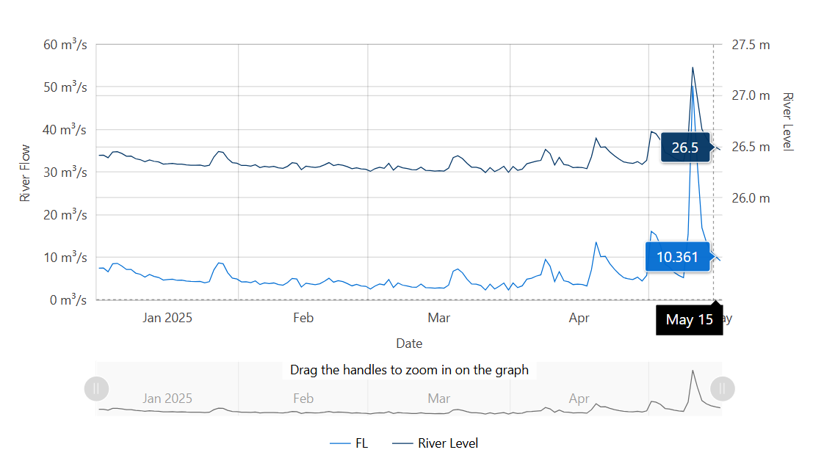
Data source: Waikato Regional Council envirohub website for environmental data.

Drinking water for livestock should contain < 100 cfu/100 mL (median value) of E. coli. Livestock Drinking Water Guidelines (2023), Australian & New Zealand Guidelines for Fresh & Marine Water Quality.

